Reeth medical centre
Annual Cancer Profile
Data Summary
October 2018

Angela Atkinson
Health Professional Engagement Facilitator
Email: angela.atkinson@cancer.org.uk
Mobile No. 07795603629

Part 1: Cancer profile data presentation

Demographics
Practice population: approx. 1,608 (lower than CCG and England average)
In 2017, 31.8% of the practice population were aged 65 or over, which is statistically higher than the CCG average of (25.1%). There is known positive correlation between age and increase risk of developing some cancers.
Practice is in 4th less deprived decile according to the IMD 2015 (1 = most deprived, 10 = most affluent) with a score of 16.5 (CCG 14.5, England 21.8)
Ethnicity estimate is 2.0% non-white ethnic groups
New cancer cases 2014/15 (count 9 – 569 per 100k population which is just statistically similar to the CCG average (666 per 100k population). (The number of persons diagnosed with any invasive cancer excluding non-melanoma skin cancer, multiplied by 100,000 and divided by the practice list)
QOF cancer prevalence stood at 3.6% for 2016/17 which is statistically similar to the CCG average of (3.5%). The England average of 2.6%. This is trending upwards.

Screening
Breast screening: Breast screening uptake 2016/17 for take up of invitation within 6 months of invitation stood at 89.5%, which was statistically similar to the CCG average (81.5%).
Breast screening (3year coverage): Breast screening uptake 2016/17 3year coverage stood at 65.9%, which was statistically lower than the CCG average of 75.9% and below national target of 80%.
Cervical Screening: uptake 2016/17, stood 76.6% which was statistically similar to the CCG average (78.5%), statistically higher than the England average was 72.1% and below the national target 80%.
Bowel Screening: Bowel screening uptake 2016/17, for take up of invitation within 6 months of invitation stood at 67.6% which is similar to the CCG average of 64.0%.
Bowel Screening (2.5year coverage): Bowel screening uptake 2015/16, 2.5 year coverage stood at 64.3% which was statistically similar to the CCG average of 64.7% and above the England average of 57.5%. The national target is 60%.

Presentation & Assessment
Two week wait referrals for suspected cancer (2016/17) were statistically higher than the CCG average. The number of referrals stood at 87 (practice rates/100,000 35410 CCG 3636).
The 2ww cancer conversion rate 8.0% was statistically similar to the CCG average at 9.8%.
Detection - The percentage of new cancers treated, diagnosed via two week wait referral, stood 69.2%, which was just statistically similar to the CCG average (55.1%).
The number of emergency presentations 2016/17 were not recorded, number is between 0 and 5. The CCG average value 110/1000,000.
The number of emergency admissions with cancer was statistically similar to the CCG average, practice count 7 (practice value 435), CCG average value 763.

Appendix.
Variation by practice 2016/17 HRW CCG. Light blue above CCG yellow- similar to the CCG and dark blue below CCG
Breast Screening Coverage by GP Practice (Females aged 50-70 screened for breast cancer in last 36 months)
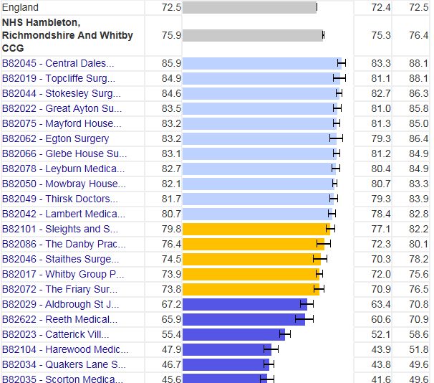

Cervical Screening Coverage by GP Practice - (Females aged 25-64 screened for cervical cancer in last 42/66 months)
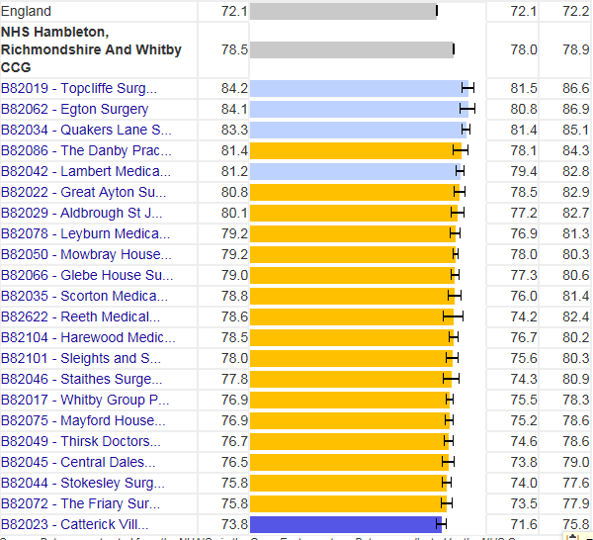

Bowel Screening Coverage by GP Practice - (Persons aged 60-69 screened for bowel cancer in last 30 months)
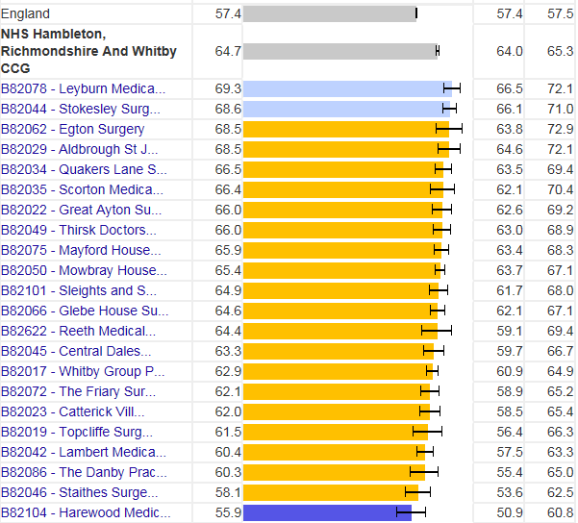

1-year screening uptake %: the number of females registered to the practice aged 50-70 invited for screening in the previous 12 months who were screened within 6 months of invitation divided by the total number of females aged 50-70 invited for screening in the previous 12 months.
3-year screening coverage %: The number of females registered to the practice screened adequately in previous 36 months divided by the number of eligible females on last day of the review period.
2.5-year screening coverage %: The number of persons registered to the practice screened adequately in the previous 30 months divided by the number of eligible persons on last day of the review period.

